Fruit Detection and Three-Stage Maturity Grading Using CNN

Harsh Mundhada[i], Saitejaswi Sanagavarapu[ii], Sanskriti Sood[iii], Rina Damdoo[iv], Kanak Kalyani[v]

[*mundhadahp@rknec.edu*](mailto:mundhadahp@rknec.edu)*,* [*sanagavarapusd@rknec.edu*](mailto:sanagavarapusd@rknec.edu)*,* [*soodsa@rknec.edu*](mailto:soodsa@rknec.edu)*,* [*damdoor@rknec.edu*](mailto:damdoor@rknec.edu)*, kalyanik@rknec.edu*

*Shri Ramdeobaba College of Engineering and Management, Nagpur, India*

*Abstract***:Agriculture is a major sector for economic growth and development and the cultivation of fruit crops is a part of agriculture thus helping in the prosperity of our nation. In recent years, there has been a sudden hike in the health problems and thus, it has led to the increasing demand for fruits and vegetables. Therefore, the use of innovative technologies is of major importance for the fruit sector to give ripe and fresh fruits. Currently, Artificial Intelligence is a technology that is transforming every line of work. Particularly, Deep Learning (DL) has diverse applications due to its potential to learn mighty representations from images. A Convolutional Neural Network (CNN) is a noteworthy class of Deep Learning architecture that is built with the capability to bring out distinctive characteristics from image data. The utmost concern of many customers, vendors and farmers is the quality of fruits and vegetables produced. Differentiating the fruits according to their ripening stages is the most crucial factor to regulate the quality of fruits. This work used a high-quality dataset with 9997 images comprising 15 fruit classes. Moreover, based on the significant applications that Convolutional Neural Networks have had till now, it proposes an analysis of deep learning algorithms for fruit detection and three-stage maturity grading and achieves 90.24% accuracy. The results obtained will help in the development of fast and accurate detection of fruits and their quality.**

*Keywords:* **Convolutional Neural Networks (CNN), Deep Learning (DL), Fruit Detection, Fruit Ripeness Detection, fruit Classification, Fruit Maturity Classification**

1. INTRODUCTION

Due to the presence of various vitamins, accessibility, and feasibility of the fruits, they have always had major contribution in human health and nutrition. There are some nutrients that only fruits can provide such as vitamin C, potassium, and folate. The major constituent responsible for the favorable illustration of fruits is its quality. But according to the UN almost 50% of the fruits and vegetables harvested globally are squandered every year due to the lack of proper storage. Therefore, there should be a method to determine the maturity level of harvested crops. The basic measure of quality for most of the fruits is their maturity. Also, harvesting during the proper maturity period is one of the main constraints for determining the quality and shelf life of the fruits. Recognizing the ripeness of fruits by humans is a wearisome, labor-intensive, expensive, error-prone, difficult, and sluggish task. Therefore, a mechanized system of fruit and its ripening detection is essential. This will reduce the manpower and time taken for such tasks. It will also improve the accuracy of the task and remove any chances of human error.

The fruit quality relies upon the fruit images that illustrates various characteristics like appearance, texture, and dimensions of the fruit. Color is the major attribute to differentiate the maturity for various fruits like apples, papaya, bananas, tangerine, mangoes, pears, and oranges. For example, oranges are green when they are unripe and turn orange when they are ripe. The same is the case with papaya as it is green and turns yellow when it is ripe.

The discernible properties of these fruits are utilized to predict their maturity, that are forecasted by their color, size, texture, and shape. This recognition process is achieved by means of a visual examination, based on knowledge of the color, size, and texture. This research work focuses on distinguishing the fruits according to their maturity, considering the unripe, fresh, and rotten stages of the given fruits: red apple, papaya, pear, cherry, and orange. So here, using convolutional neural networks (CNN) algorithm.

This work demonstrated the viability of our point of view by using a dataset containing 9997 images of five fruits, to build a model that can be implemented to recognize 3 classes of ripening status. We have created the dataset by extracting images using the OpenCV library from the videos we have captured. We have also used some images from the dataset fruit-360 mentioned in the [4]. We have segregated the images of a single fruit into three categories: unripe, fresh, and rot.

In paper [4] authors have introduced a dataset Fruits-360 which contains various images of fruits but they are only segregated based on the type of fruit and not on their level of maturity or ripeness. They have also trained a deep neural network that could identify fruits. The fruits were sorted based on the type. We have used images of fruits from dataset fruits 360 and segregated them according to their ripeness. In paper [1]**,** authors have used modified VGG-16 to classify papaya into three categories: mature, partially mature, and immature. The dataset presented in this was very small. In paper [2] authors have tried to combine RGB and NIR multi-model images inside a DCNN framework for fruit detection.

1. RELATED WORK

The authors of [1] have classified papaya fruits into 3 categories: mature, partially matured and unmatured. They used CNN, a deep learning method that is used for image processing and its recognition. They acquired an accuracy of 100% along with 1.86 minutes of training period using a classification model of VGG16. The work by Selly Anatya et al. [2] have used a total of 5030 images for training a model to differentiate a fruit in five different categories. The total number of subclasses were 52. The classification accuracy achieved in the paper for 1294 images were 61%. The authors of [3] have proposed an automated and well-organized fruit maturity detection and counting system using Image Processing that can help the management of the crops by imparting crucial statistics to foretell yields, to schedule different harvesting schemes, or to gain more efficiency.

The work by Mureșan, Horea & Oltean, Mihai et al. [4], proposed a new dataset of images consisting of fruits titled as Fruits-360, comprising of 90483 images of fruits and vegetables with 131 classes and also training a deep neural network model that is proficient of recognizing different fruits from the given dataset. The authors of [5] have proposed two different algorithms to recognize the maturity of grapefruit from the images of the given dataset and compared them. The two algorithms were: Convolutional Neural Networks and Support Vector Machine model. The highest accuracy of 79% was achieved by the CNN classifier model whereas an accuracy of 69% was recorded for Support Vector Machine model. The authors of [6] used natural outdoor RGB-D images to developed a model that identifies the maturity stage of passion fruits. The ripening states were classified into five different categories: young (Y), near-young (NY), near-mature (NM), mature (M), and after-mature (AM). It was affirmed that the presented model achieved the recognition accuracy of 92.71% and classification accuracy of 91.52%. The work by F. Mazen and A. Nashat et al. [7]**,** authors have presented an automated system to detect the various maturity stages of bananas. They have used an Artificial Neural Network based framework which employs the use of different colors to make a four-class database. The growth of brown spots has been used for segregating the bananas into different ripening classes. By comparing the result of the presented model to other related algorithms such as discriminant analysis classifiers, decision tree, the KNN, the naïve bayes, and the Support Vector Machine, it was found that the highest result, 97.75%, was achieved in the same model.

The authors of [8] mentioned that the significant parameters of fruits for classification and grading are majority of external features of fruits like texture, color, shape, size, and other flaws. Nowadays, manual work of fruit recognition and grading has been superseded with automated machine vision systems because of the evolution in the machine and an increased availability of feasible software and hardware. Authors of [9] demonstrated that texture measurements are required because of unevenly colored or achromatic surfaces. Combination color and texture is an important criterion to achieve better results. Simultaneously the authors have minimized the computational complexity to its lowest. The shape and size features along with color and texture have been combined to improve the overall functionality and make the system more flexible. The identification rate can be enhanced by increasing the number of images while training. The authors of [10] have used two classes of deep neural networks namely MixNet and EfficientNet to develop a proficient system that can identify fruits with considerable accuracy. This approach can be executed using a handy device with limited computational resource to provide exceptional accuracy and brisk results. The systems performance is affirmed by a dataset which accommodates 48,905 images for training and tested by 16,421 images. According to the obtained results it has been confirmed that the overall prediction accuracy using the architecture EfficientNet and MixNet has been exceptional as compared to conventional baseline.

1. METHODOLOGY
2. ***Dataset***

We have used Fruits-360 dataset by extracting images from recording videos of fruits and. The images from the Fruits-360 dataset were not annotated or segregated according to the ripeness or maturity but instead according to the type of fruit. The dataset did not contain the images for all the 3 stages of every fruit so we captured and added them to the existing dataset. The videos were captured under proper illumination and plain white background. After recording, the video frames were extracted from the videos. We have used the OpenCV python library to extract frames from the video. After extracting the videos, we removed the background, reduced the noise from the images, and then cropped the image to focus on the fruit for better feature extractions. The preprocessing of images is depicted in Fig 1. The training dataset contains a total of 9997 images of 5 different types of fruits which include orange, pear, cherry, apple, and papaya. There are a total of 15 classes as we have divided each fruit into 3 categories:

1. Unripe
2. Ripe/Fresh
3. Rot

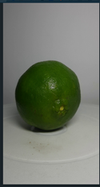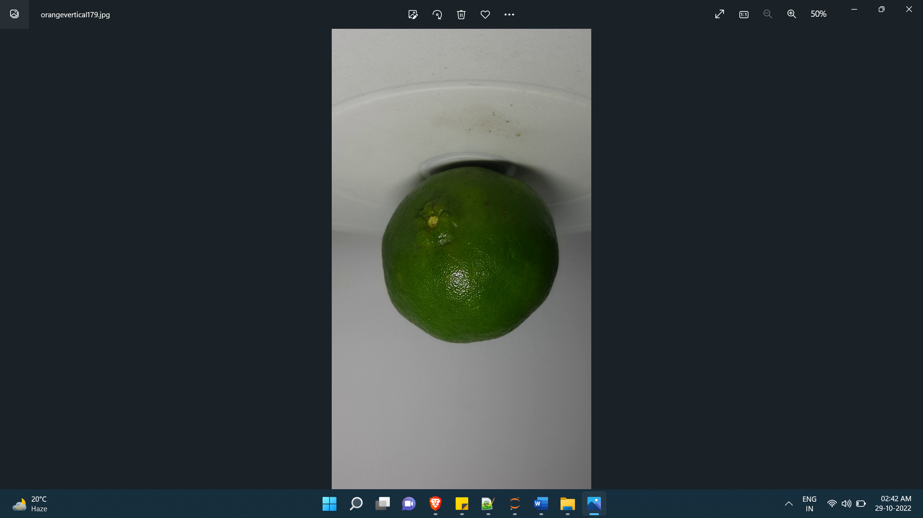



Fig. 1: a) Frame extracted from video, b) Image after cropping, c) Image after removing the background

Fig. 2 presents the sample images from the dataset. We have split the dataset as 80 percent and 20 percent for training and testing purpose.

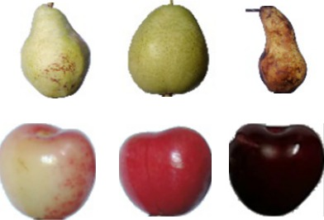

|  |  |  |
| --- | --- | --- |
| a | b | c |
| d | e | f |

Fig. 2: Sample fruit images from the dataset

a) Unripe Pear, b) Ripe Pear, c) Rot Pear, d) Unripe Cherry, e) Ripe Cherry, f) Rot Cherry

***2. Architecture***

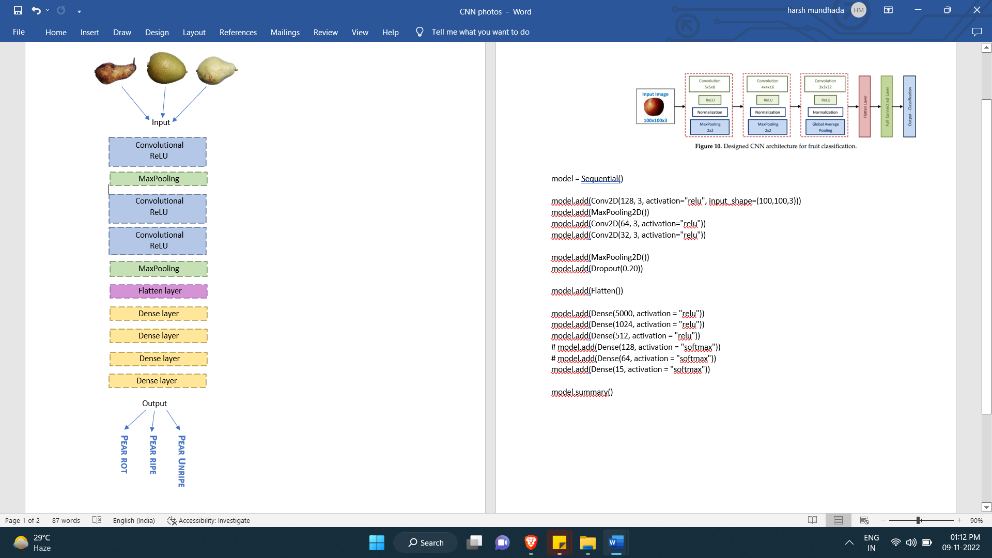The purpose of the work is to replicate the human vision in a CNN-based architecture which is proficient in segregating the fruit and its maturity stage just by examining a picture of it. After analyzing the literature, we have used a Sequential model of 10-layer convolutional neural network as shown in Fig 3. The neural network structures we are using consists of 3 convolutional layers intertwined with 2 max pooling layers. The output layer succeeds the last max-pooling layer which consists of one dropout layer, one flatten layer and four dense layers to reduce the dimensions and execute the maturity stage grading for the fruit. Using the Dropout layer, the number of neurons in this hidden layer was minimized to reduce overfitting. We have used total of 4 dense layers after implementing the flattening layers. The first dense layer, consisting of 5000 neurons, takes flattened image input from the preceding max-pooling layer. Successively, two more dense layers are implemented with 1024 and 512 neurons respectively. In the end, to predict each category of the fruits, a dense layer with 15 neurons was utilized as the output layer. In Table 1 we present the model configuration.

Fig 3: 10-layer convolutional neural network Architecture of the model

Table 1: Model configuration

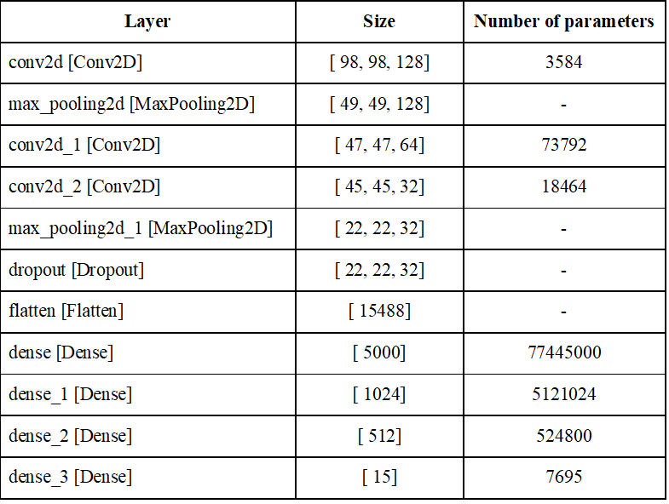

***3. Results***

In this segment we put forward the outcomes of training the model on our dataset with different layer configurations. We experimented with the dense layers and convolutional layers, each connected by a MaxPooling layer followed by a dropout and flatten layer. The results are presented in Table 2. We achieved the maximum accuracy 90.24% with 11-layer architecture with 4 dense layers and 3 convolution layers. In Fig 3 shows training and testing accuracies for the same.

Table 2: Results of training the model on the dataset based on different layer configurations

|  |  |  |
| --- | --- | --- |
| Layer Configuration | Training accuracy | Testing accuracy |
| 11 Layer Configuration  (5 dense layers, 2 convolutional layers) | 70.07% | 75.10% |
| 9 Layer Configuration  (3 dense layers, 2 convolutional layers) | 79.50% | 86.72% |
| 10 Layer Configuration  (4 dense layers, 2 convolutional layers) | 82.50% | 85.16% |
| **11 Layer Configuration**  **(4 dense layers, 3 convolutional layers)** | **89.22%** | **90.24%** |

Table 3: Results of testing the model using final 11-layer configuration with constant epoch value = 40 on the dataset based on different values for batch size

|  |  |
| --- | --- |
| Batch Size | Testing Accuracy |
| 8 | 90.24 |
| 16 | 90.00 |
| 32 | 87.31 |

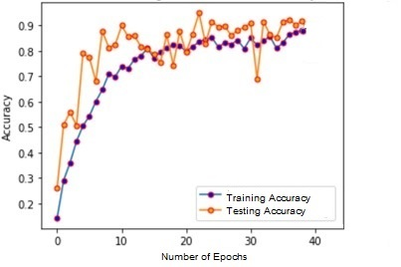

Fig. 4 Training accuracy and Testing accuracy

1. CONCLUSION

The research revolves around a 10-layer convolutional neural network for the detection and classification of the training dataset containing a total of 9997 images of 5 different types of fruits which included orange, pear, cherry, apple, and papaya. It analyzed how fruit ripeness degree detection is an important factor in the agriculture field. The project is mainly focusing on reducing human effort and making their life easier. The applied CNN architecture is a very mighty technique for deep learning approaches that successfully recognizes the fruits and performs fruit classification based on three different stages, that is, unripe, ripe, and rot. We have successfully trained this model using 15 classes. This model had given 90.24% accuracy in fruit ripening recognition and its classification. The outcomes highlight that the presented research can be utilized to help people like farmers to differentiate fruits on the basis of quality and user while shopping fruits. After generalizing, various techniques of Convolutional Neural Networks and different deep learning methods, they have provided better results as compared to that of conventional deep learning methods. These methods may be analytically strenuous for training procedures but can be carried out in the easy-to-use computing devices for example mobile phones. This could be applied using the presented model which has only 3 convolutional layer and 4 dense layer to segregate fruits in different stages of maturity using portable device. Thus, we present a 3-stage fruit maturity grading model by using CNN architecture.

REFERENCES

[1] Marah M. Al-Masawabe, Lamis F. Samhan, Amjad H. AlFarra, Yasmeen E. Aslem, Samy S. Abu-Naser (2021), “Papaya maturity Classification Using Deep Convolutional Neural Networks”, International Journal of Engineering and Information Systems (IJEAIS) ISSN: 2643-640X

[2] Selly Anatya, Viny Christanti Mawardi Janson Hendryli; **“**Fruit Maturity Classification Using Convolutional Neural Networks Method**”.** IOP Conf. Series: Materials Science and Engineering 1007 (2020) 012149

[3] Vina M. Lomte, Shalmali Sabale, Rugveda Shirgaonkar, Pranali Nagathan, Priyanka Pawar; **“**Fruit Counting and Maturity Detection using Image Processing**”:** A Survey (2019) www.ijresm.com | ISSN (Online): 2581-5792

[4] Mureșan, Horea & Oltean, Mihai. (2018). **“**Fruit recognition from images using deep learning**”**. Acta Universitatis Sapientiae, Informatica. 10. 26-42. 10.2478/ausi-2018-0002.

[5] Kangune, Kaveri & Kulkarni, Vrushali & Kosamkar, Pranali. (2019). **“**Grapes Ripeness Estimation using Convolutional Neural network and Support Vector Machine**”**. 1-5. 10.1109/GCAT47503.2019.8978341.

[6] Myint San, Mie Mie Aung, Phyu Phyu Khaing, **"**Fruit Recognition Using Color and Morphological Features Fusion**"**, International Journal of Image, Graphics and Signal Processing (IJIGSP), Vol.11, No.10, pp. 8-15, 2019.DOI: 10.5815/ijigsp.2019.10.02

[7] F. Mazen and A. Nashat, **“**Ripeness classification of bananas using an artificial neural network,**”** Arabian Journal for Science and Engineering, vol. 44, 01 2019.

[8] Sapan Naik Bankim Patel; “Machine Vision based Fruit Classification and Grading” - A Review International Journal of Computer Applications (0975 – 8887)

[9] Arivazhagan, Shebiah, et al. "Fruit recognition using color and texture features." Journal of Emerging Trends in Computing and Information Sciences 1.2 (2010): 90-94.

[10] Linh T. Duong, Phuong T. Nguyen, Claudio Di Sipio, Davide Di Ruscio, Automated fruit recognition using EfficientNet and MixNet, Computers and Electronics in Agriculture, Volume 171,2020,105326, ISSN 0168-1699

[11] Akhil Kumar, Arvind Kalia, & Akashdeep Sharma. (2020). Object Detection: A Comprehensive Review of the State-of-the-Art Methods. *International Journal of Next-Generation Computing*, *11*(1), 52–75. https://doi.org/10.47164/ijngc.v11i1.172